Guided Capstone Project Report - Big Mountain Resort

Springboard Data Science Career Track

Leo Evancie

Montana’s Big Mountain Resort hired this firm to identify what changes to the park, if any, could reduce operating costs and/or drive ticket prices up. Inherent to that task was to analyze competing resorts, and key state-level information, to develop a model ticket prices. This would help evaluate Big Mountain’s current ticket prices compared to its competitors, as a factor of key resort facilities and features. With the recent addition of a new chair lift (increasing operating costs by $1,5 million), the resort needed this information as soon as possible to help guide their decisions to alter facilities, raise prices (and by how much), or both.

First, we received comprehensive data about 330 ski resorts across the US. To gain context for things like total state area and population, with which we could calculate new per-capita or per-square-mileage columns, we also imported state-level data from Wikipedia. There were erroneous values in the data (e.g., showing 2019 as the number of years in operation), which we corrected with some research. With seven resorts’ adult weekday prices missing, we dropped that column entirely, focusing instead on adult weekend prices. We were only missing four of those prices, so we dropped those resorts from our analysis.

We produced a series of histograms to provide comparison for Big Mountain’s various features:

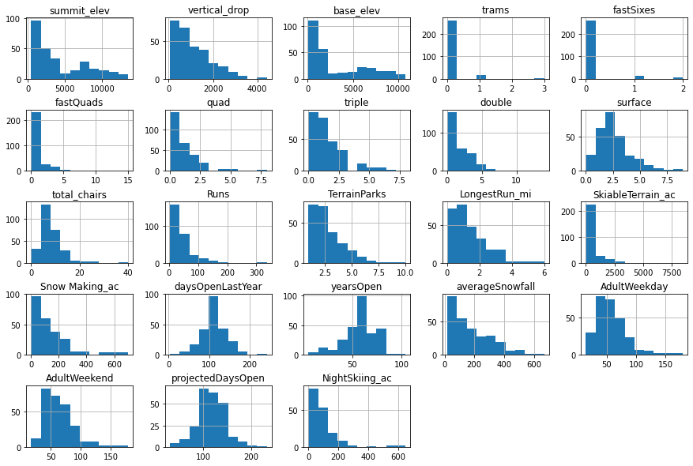

Some exploratory data analysis led us to conclude that while there did not appear to be clear by-state groupings for ticket price, the inclusion of state data did seem to be important for feature selection. For example, there was a positive correlation between ticket prices and resort night skiing state ratio. Meanwhile, ticket price was also correlated with fastQuads, vertical drop, runs, trams, snowmaking area, days open last year, and a few others. A heatmap of correlations between all variables is shown below, with the “AdultWeekend” feature being of most interest for our later modeling purposes:

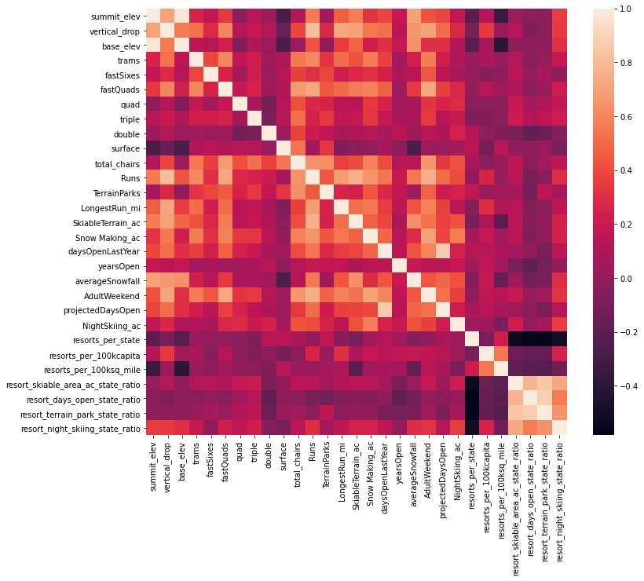

Then, we turned to our machine learning toolkit to test various model types and look for which fit our data the best. We ultimately chose a “random forest” model, which performed well in terms of predicting ticket price based on a number of key categories. As would be no surprise after seeing the above heatmap, our model ranked the number of fast quads, total runs, snowmaking area, and vertical drop as the most important for predicting ticket price:

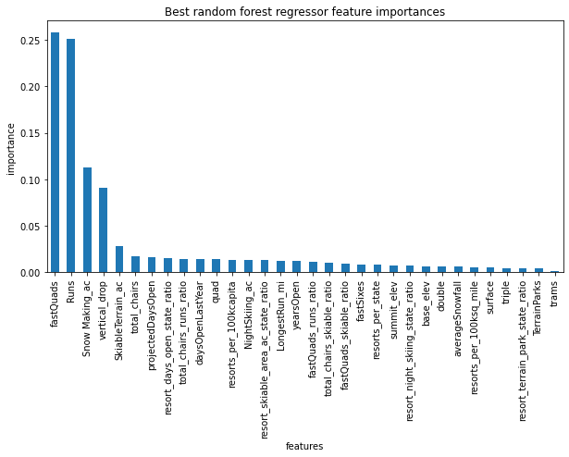

Pointing our model at Big Mountain (which had been left out of the training data for greater accuracy), we calculated an expected ticket price of $95.87, with a mean absolute error of $10.39. This puts the resort’s current $81 ticket below the range of what our model predicts, providing support for a decision to increase ticket prices.

What accounts for this potential under-pricing? Big Mountain ranks among the highest in the market on what we determined to be key cost-driving facilities, for example:

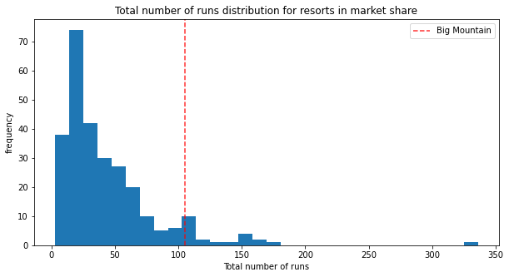

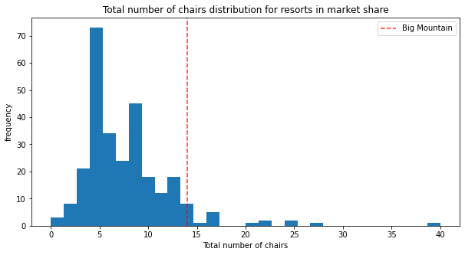

It is entirely plausible that Big Mountain has underestimated the value of its facilities, and that skiers would pay a bit more to continue enjoying a premium ski resort.

As far as the operational changes put forward by the executive team, we found that dropping ten runs form the resort would support a ticket price reduction of around $1.75, although there is slim cost associated with closing just a couple of runs:

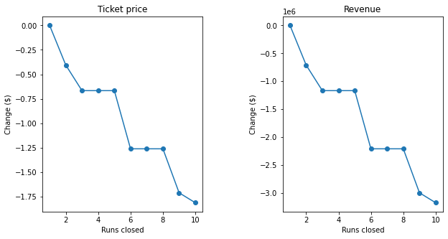

On the other hand, increasing the vertical drop would support a ticket price increase of $1.99. Given the projected number of visitors, this could mean a revenue increase of $3,474,638. Adding a commensurate four acres of snowmaking area does not increase the predicted ticket price at all, so we judge that to be an unnecessary addition to the plan.

With the new chair lift costing $1,5 million, the $3,5 generated by a $1.99 ticket price increase would more than balance the books. Costs could be reduced even further by closing one or a small number of the least-used runs, although we advise caution here, as closing even one run would mean a slight reduction in ticket price (see above).